This document provides instructions for creating an exam using the D2L quiz builder. (So we use “quiz” and “exam” interchangeably, though D2L uses “quiz”.) Some of it (including screen captures) is based on the authors’ experience. Some is paraphrased or directly quoted from “brightspace” (synonymous with D2L) documentation. That documentation is excellent.

Click on the triangle next to a Topic below to Expand that Topic.

Create, Name, and Categorize new exam

- Click on the drop-down menu for “Assessments” and click on “Quizzes.”

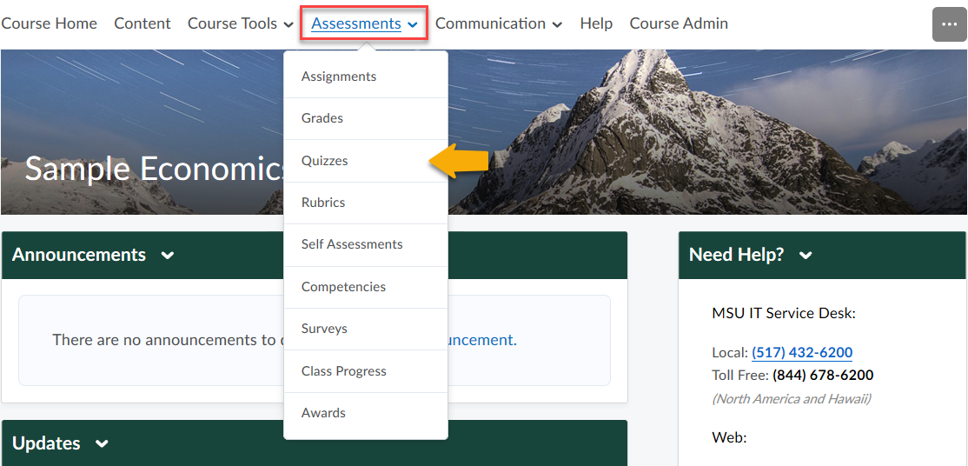

- Click on “New Quiz.”

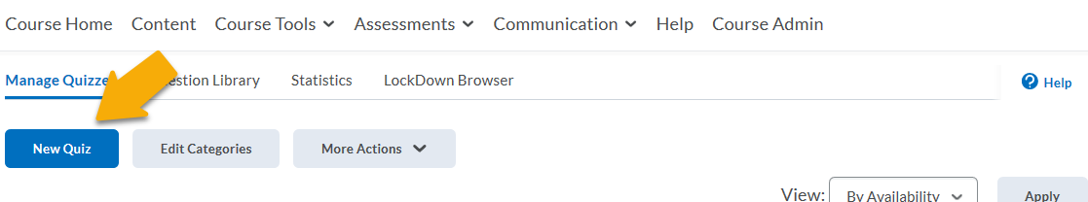

- Click on the “Properties” tab if it is not already open. Give the exam a name. You can also add a category to make it easier to find assessments with similar or related content. Read about categories in D2L documentation here.

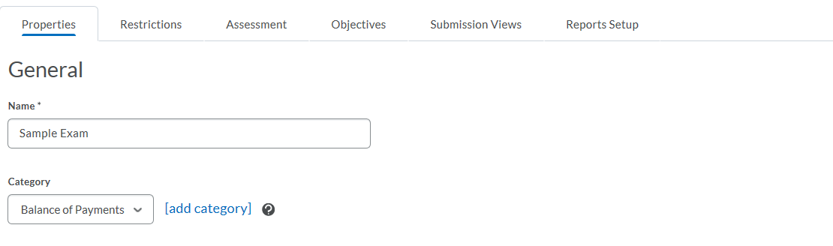

Add Introduction, Description, Headers/Footers

Under the “Properties” tab of your Quiz, add an “Introduction” and “Description” if you wish. Make sure to select the “on” radio buttons to display the Description and Introduction fields. You can also have headers and/or footers if you have multiple pages. The following descriptions come from here.

- The Description appears in the table of contents, and tells the learner what the quiz is about before they click into it. Providing a brief overview of the quiz and quiz topics will help learners determine if they are ready to take the quiz, or whether they need to review a particular topic that it includes; you can include images, videos or hyperlinks.
- The Introduction appears on the main start page of a quiz. This is where you can provide any specific instructions about taking the quiz. Fill out this field with any text, images, videos and hyperlinks that introduce the Quiz.
- Headers and Footers are optional, but if you’d like to include these in your Quiz, ensure one, either, or both are turned on. The page header is shown at the top of every page in the Quiz, and the footer is shown at the bottom; these are ideal if your quiz is multiple pages and you would like to provide additional instructions/reminders throughout the quiz.

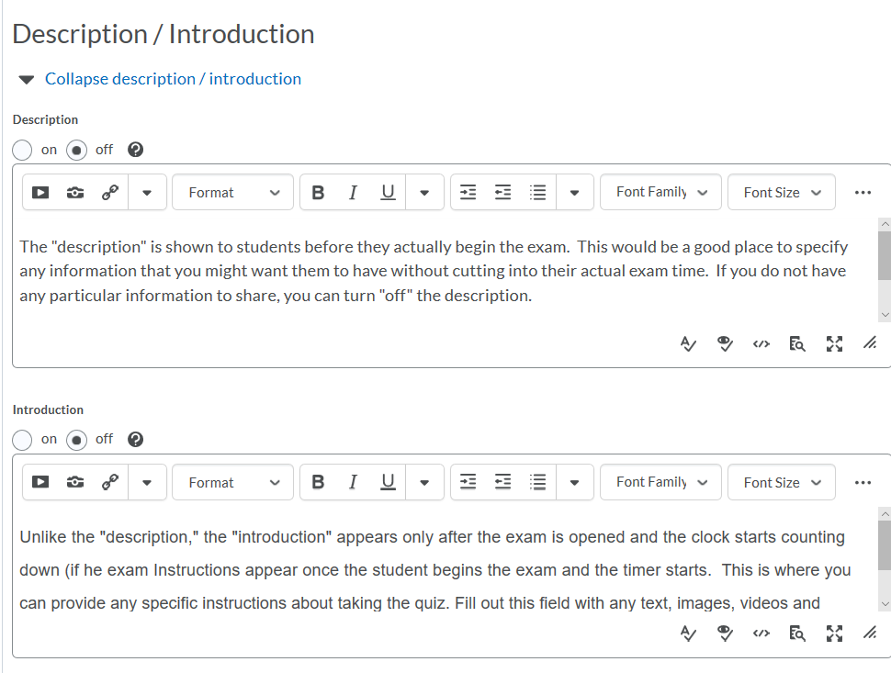

Populate Exam with Questions, Randomization, Exam Layout

- Click the Add/Edit Questions button to populate the exam with questions. D2L supports many different question styles, and there are multiple ways of entering questions. Brightspace/D2L has excellent documentation explaining these options.

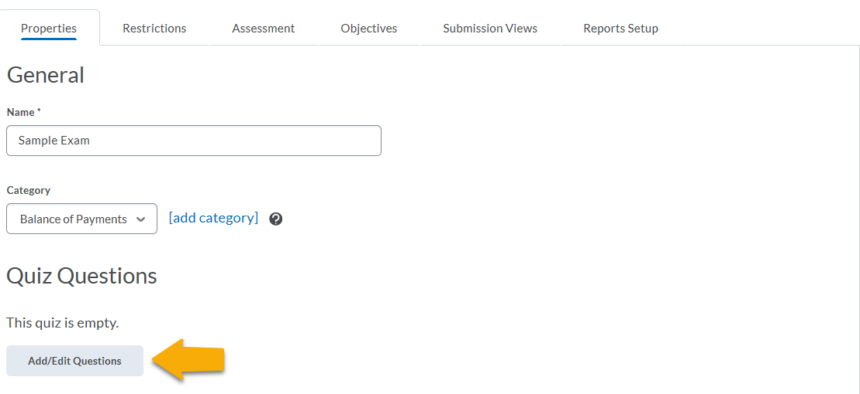

- A simple way to add questions is to do so manually in D2L. This is done (after clicking on “Add/Edit Questions”) by clicking on Add, then New Question, then question type, and entering the question and its properties. These are then stored in the given Quiz, and can also be added into a future Quiz (using “Import”, then “Browse Question Library”, then selecting the source Quiz from the “Source: …” dropdown menu).
- Another method is to import questions from files. This can be done (after clicking on “Add/Edit Questions”) by clicking on “Import”, then “Upload a File”. The file must be in a D2L-specific CSV format; a template file is available for download after you click through to “Upload a File”. If you keep a test bank in Word or other formats, you can cut and paste them manually into Excel in the D2L CSV format with some extra work. Alternatively, you can reformat your questions in Word in a specific way and use the following utility to convert them to D2L CSV format.
- You can add to or edit questions by clicking on Add/Edit Questions. For every question entered, you can enter the correct answer, the number of points it is worth, and whether answer order should be randomized. Randomizing answer order makes collusion harder, but should be avoided if question order is important, e.g. when using “all of the above” or “none of the above”.
- You can also add a Figure, mathematical equation, or other object to the display of a question. Do this by clicking on the question (after clicking on “Add/Edit Questions”), then clicking in the box for the question text. Clicking on the camera icon allows you to upload an image. Clicking on the Σ allows you to enter an equation, in Latex or equation editor. Clicking on the Full-screen icon allows for more choices for font and objects to insert.
- A handy way of organizing and randomizing questions is available through Question Pools. These enable you to populate an exam by selecting randomly or exhaustively from one or more Sections of questions that you create and store in a D2L Question Library. For example, you could create a unique 50-question exam for each student by using 10 Question Pools – corresponding to 10 sections of material, say – from each of which D2L randomly draws 5-question subsets. Or, you could have several similar versions of a single question, and draw a version randomly for each student from a Question Pool. For example, you could have 2 versions of each of 30 questions, and each student gets a random draw for each question.
  - The first step is to create a Question Library; click on “Assessments” then “Quizzes”, then the “Question Library” tab. To create a new Section, Click on “New”, then “Section”. You will name the Section and can choose to randomize the order of questions from this Section.
  - Populating a newly created Section of the Question Library is simple. Click on the name of the Section in the “Question Library” list. Then you can create new questions manually, or import them from file(s), as described above.
  - Question Pools can be created from these Sections of the Question Library to populate some or all of the exam. This is done (after clicking on “Add/Edit Questions” in your exam) by clicking on “Add”, then “Question Pool”. You can then name the Question Pool and, by clicking on “Browse Question Library”, select the Section(s) of the Question Library from which you want to draw your questions. You also indicate how many questions to draw from the selected Section(s); if less than the total number of questions, D2L randomly selects the correct number for each student. A Question Pool can collect from one or more Sections of the Question Library.
- Once there are some questions in the Quiz, you can choose to randomize question order. This is done when editing the Quiz (under “Assignments”, “Quizzes”, then edit this Quiz), under the “Properties” tab, by checking “Shuffle questions at the quiz level”. This is useful for making collusion harder.
- In the “Properties” editing section described in the previous bullet point, you can set “Questions per Page”, i.e. the number of questions that appear to the students on each page. Make sure to click “Apply” to set these page breaks, after finishing your exam. Setting questions per page to one and randomizing question order makes collusion more difficult. Collusion is even harder if you check the “Paging” box, which prevents students from revisiting questions on pages they have left; however, this arguably burdens some non-cheating students significantly as well.

Set Availability, Deadline, Time Limits: In general, and special cases

Click the “Restrictions” tab of your Quiz to make the exam visible, and set dates for when the exam is first available, when access ends, and when the exam is due.

- Uncheck “Hide from Users” to make the exam appear on the student’s content page in D2L. This is checked as a default, allowing faculty to work on an exam without students seeing it. This step is important; before you do this, the exam is invisible and not accessible to the students, regardless of other settings.
- The exam is still inaccessible to students before the “Start Date”. Even if “Hide from Users” is unchecked, the exam is greyed out and not clickable until the Start Date. If no Start Date is set, the exam is clickable as soon as “Hide from Users” is unchecked. The Start Date is displayed to students when the exam is made visible.
- The exam cannot be entered by students after the “End Date”; it is greyed out and not clickable after this date. If no End Date is set, Exam access continues until course access ends. A student who already entered the exam before the End Date can still work on it and submit it after the End Date, subject to any enforced time limits (see below). The End Date is displayed to students when the exam is made visible.
- The “Due Date” is also displayed to students when the exam is made visible, as in “Due on X”. D2L automatically flags as late any exam submitted past this Due Date. It does not stop students from working past the Due Date. (You can use the “Grade” function in the dropdown menu by your Quiz, then click the Attempt Logs button, then the Detailed tab, to ascertain what questions were answered past the Due Date.)
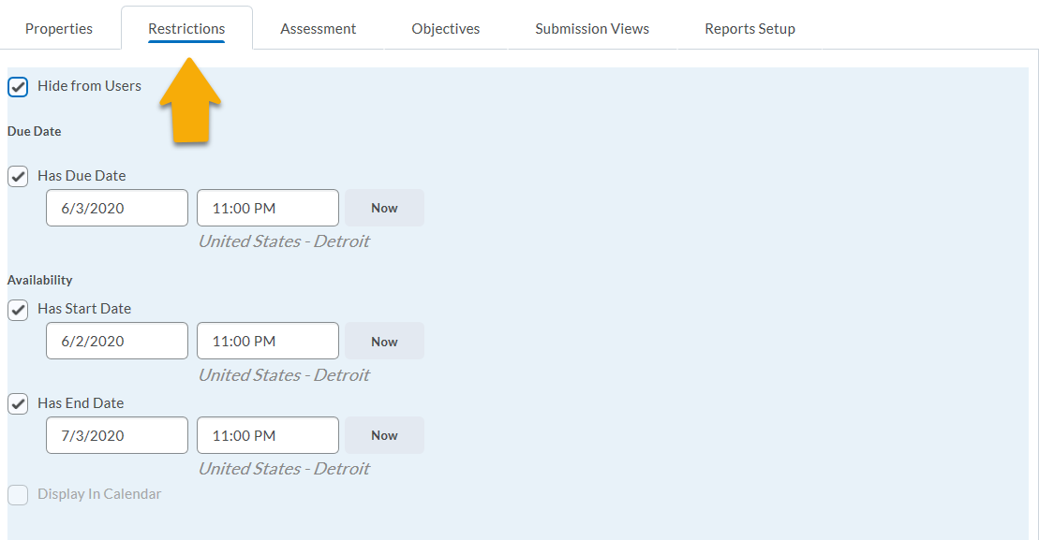

- Scrolling down to “Timing”, you can set a D2L-enforced Time Limit for the exam. This Time Limit applies from the moment the student begins the exam (and thus may extend past the End Date). The Time Limit can be either recommended or enforced; either way, the student sees a clock ticking down. If you wish to enforce the limit, you have options of allowing the student to continue working (but D2L flags quiz attempt as late); preventing further changes to the exam after time expires; or allowing to continue working but auto scoring the exam as a zero once time expires (which pops up a box for an “Extended Deadline”, a second grace period). In the case of an enforced limit, you must set a grace period (experimentation suggests that “0 minutes” is not an option), which begins once the clock runs down to zero.
- Scrolling down to “Special Access”, you can set different availability, due date, and time limits for individual students. For example, a student might have a VISA permitting 50% more time. You can do this by checking “Allow selected users special access…” and clicking “Add Users to Special Access”. From there, you select the student(s), set the special conditions (Start Date, End Date, Due Date, and/or Timing Restrictions), and click “Add Special Access”. The results should then be visible below the “Special Access” heading (when in the “Properties” tab).

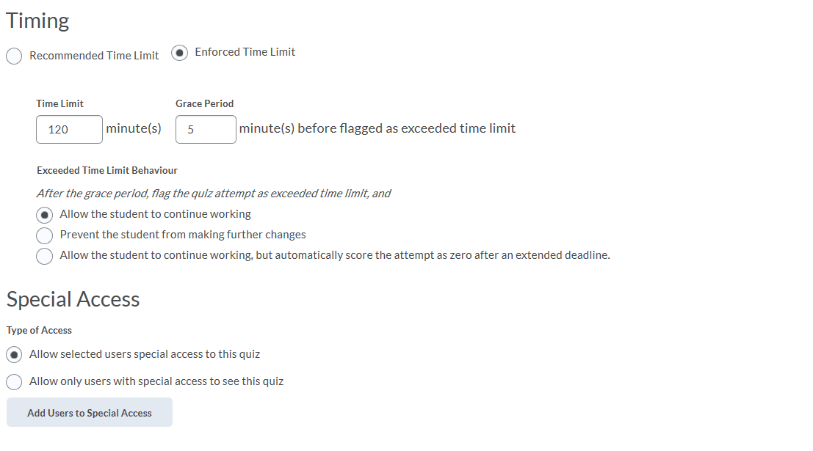

Add pre-Conditions for Taking the Exam (e.g. Honor Code assent)

It is possible to add conditions that must be satisfied before students can access the exam. For example, you might require a minimum score on a pre-test. One way to use this feature is to create a pre-test that requires students to assent to the conditions under which the exam is given. The following three-question quiz is an example of how you might give students the opportunity to affirm their intent to be honest. Each question was created as a multiple-choice question with only one answer choice.

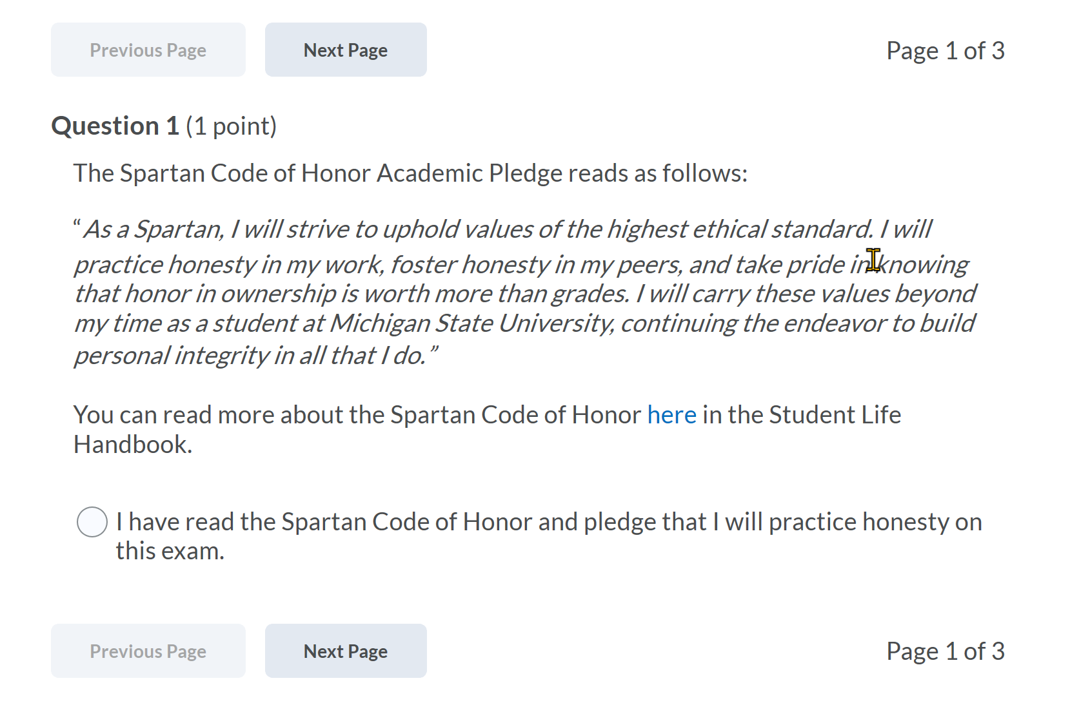
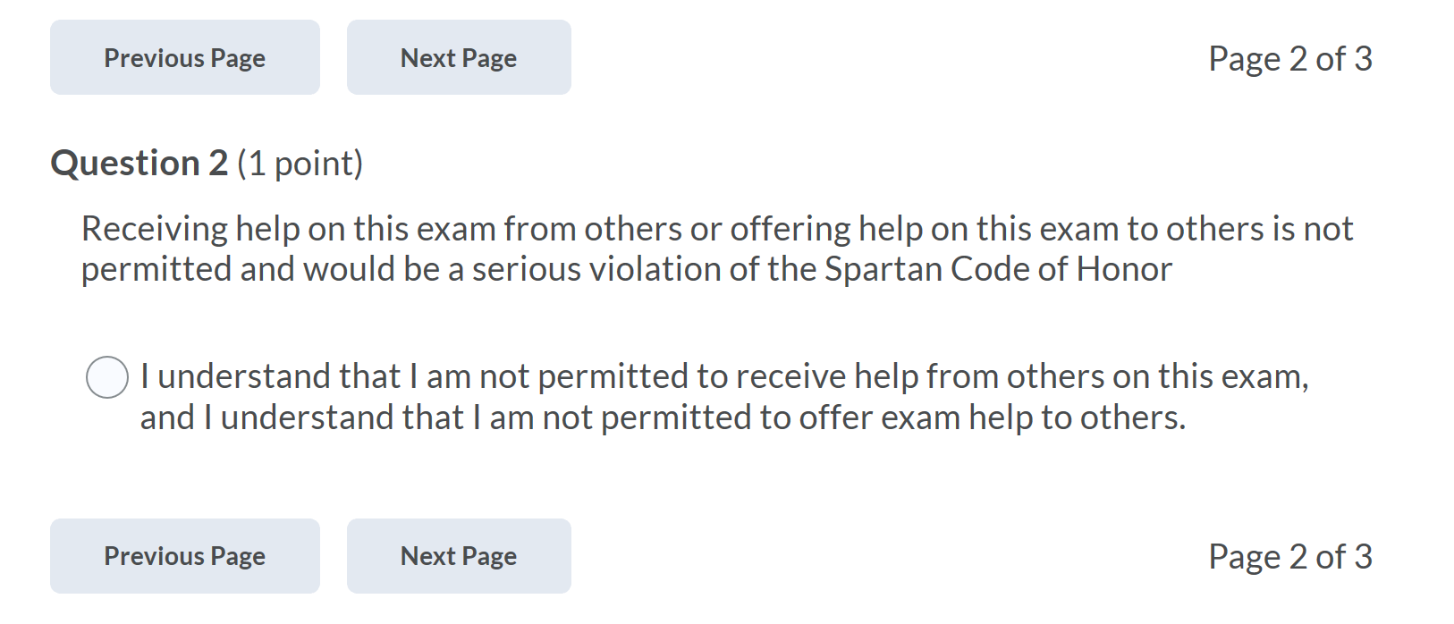

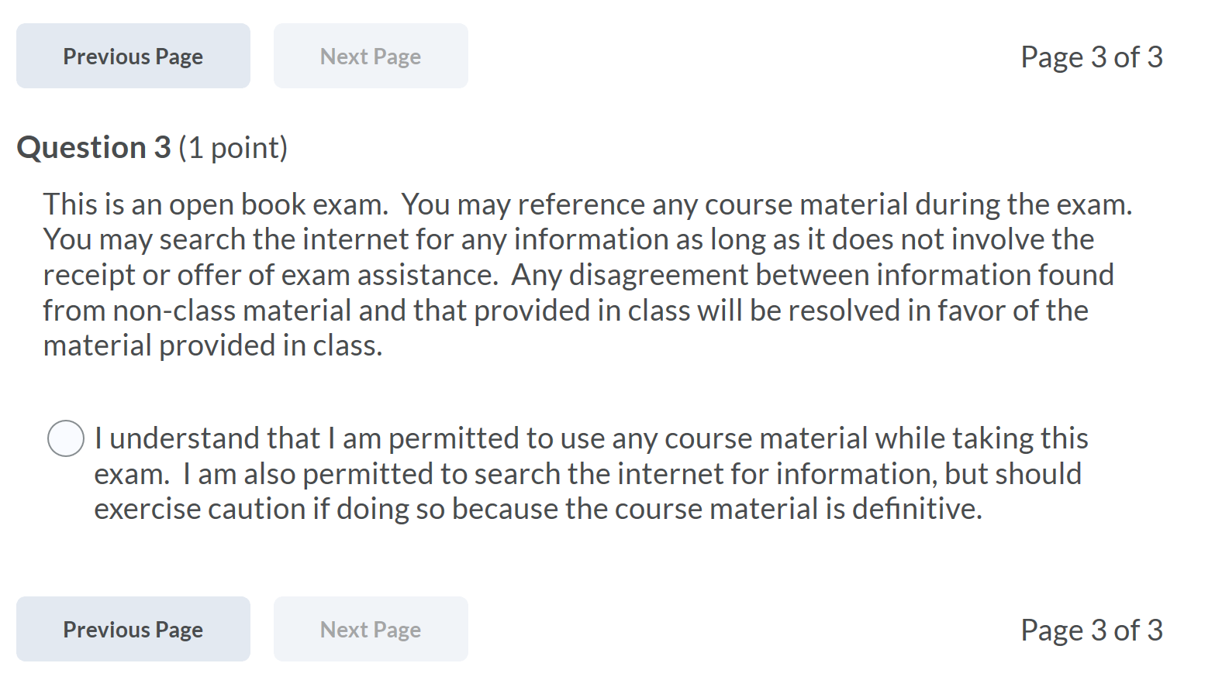

- To add release conditions, navigate to the “Restrictions” tab.

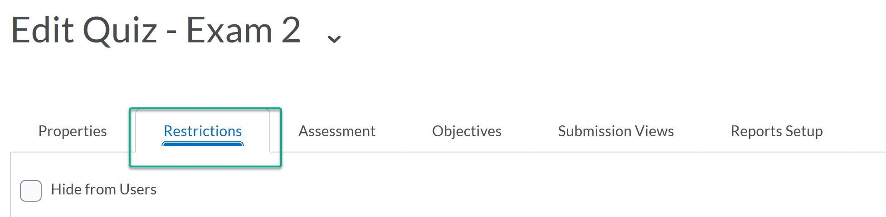

- Click “Create and Attach,” which is found just under the date and time settings.

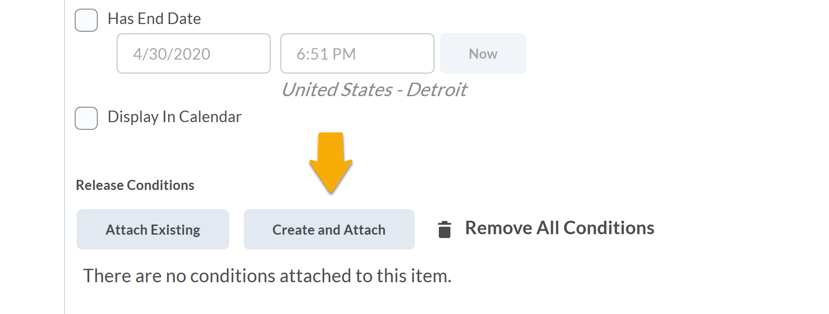

- This opens a new window that has a dropdown menu with a large selection of possible conditions. In this example, choose “score on a quiz”

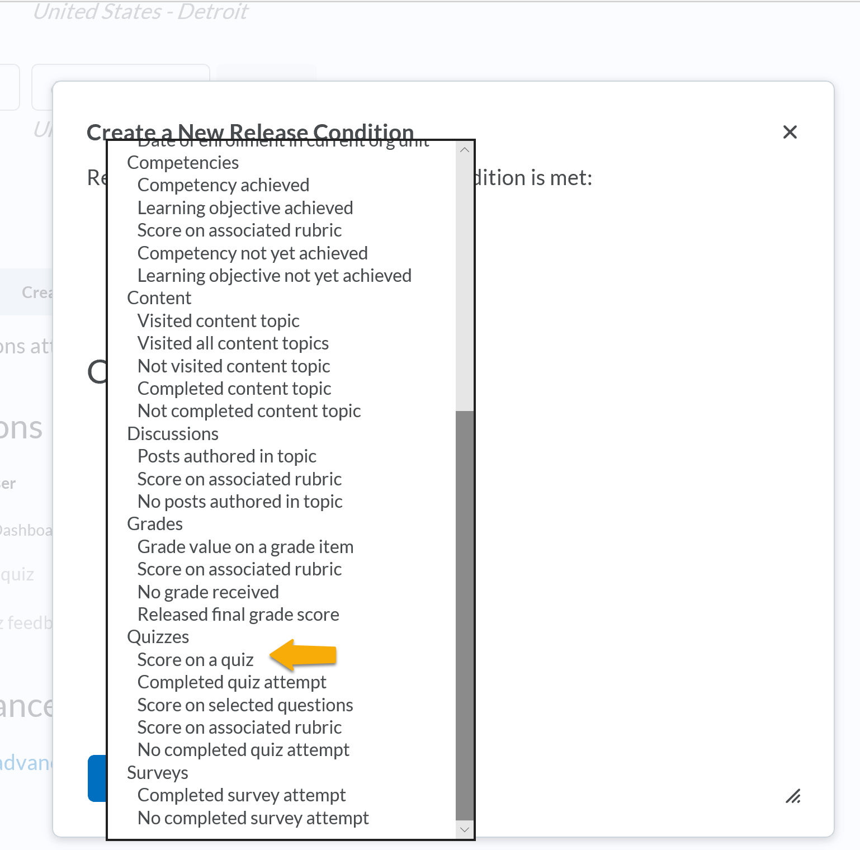

- Clicking on the link opens a new window, allowing you to select the particular quiz that serves as the pre-test for the current exam.

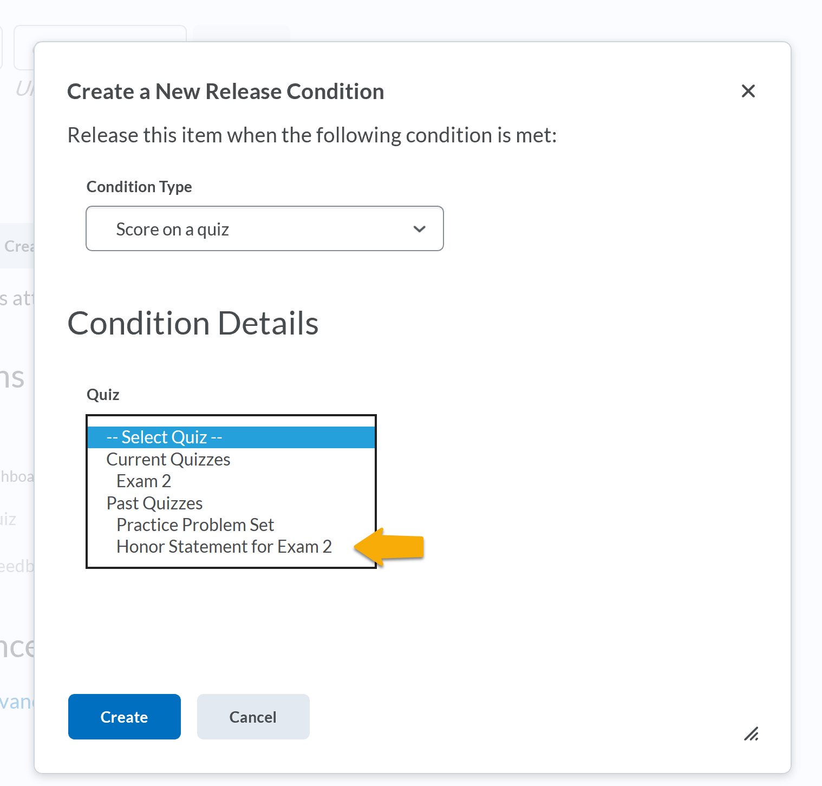

Determine what Students can view After Exam

You can control what information students see once they complete the quiz. The information could be as limited as a statement indicating that their quiz was submitted, or as expansive as showing all questions with the correct answers. In the case of a live exam, it might be wise to delay displaying answers; this is do-able, see below.

- When Editing the Quiz, click on “Submission Views” tab and follow the “Default View” link.

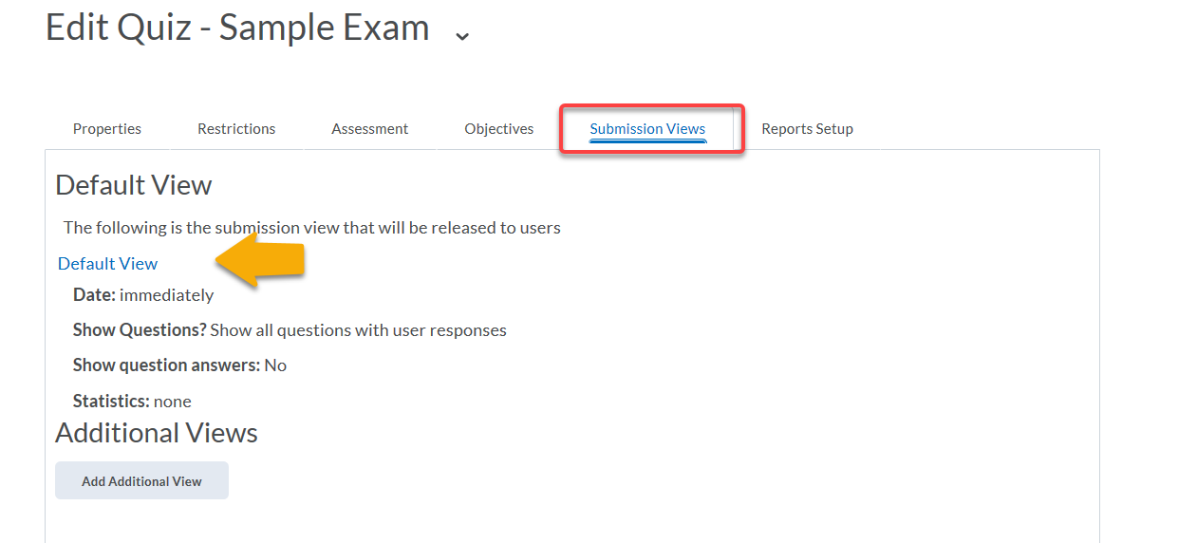

- Provide the message that is displayed after submission, and choose whether students will be allowed to see the questions and/or answers upon submission.

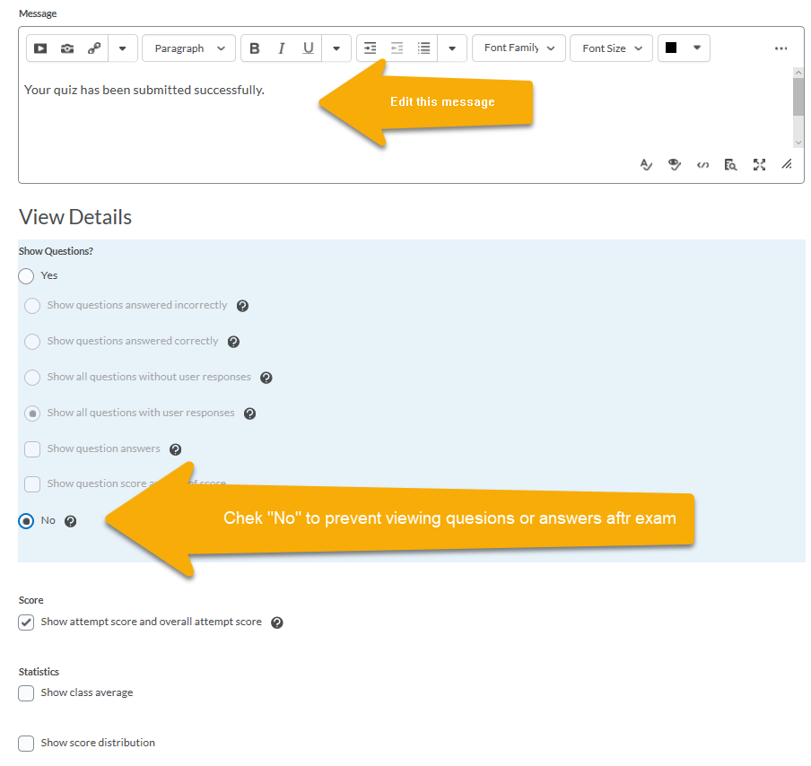

- Return to the “Submission Views” tab to create additional views. In this example, students would be allowed to see all questions and answers. This view is not actually visible until the box is checked. It can also be withheld until a certain date and time.

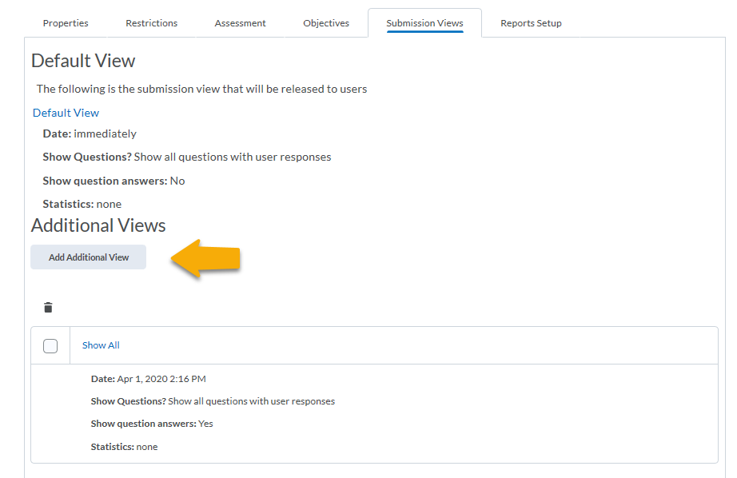

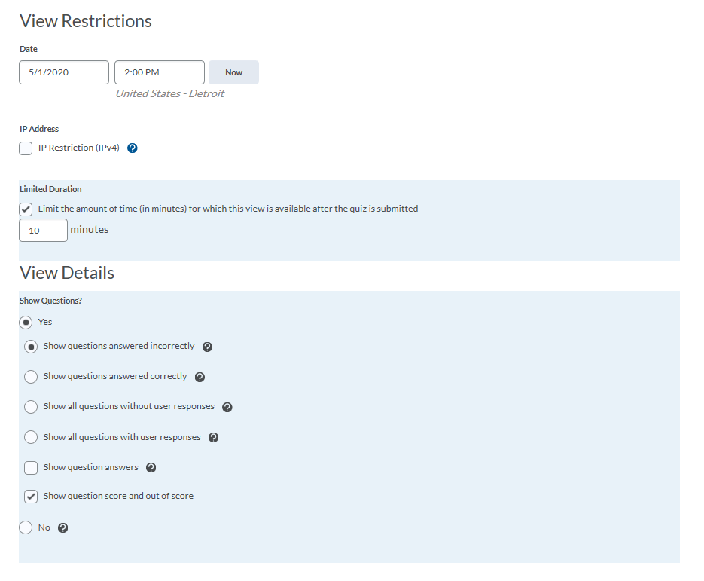
Here is an example where the additional view is not available until May 1. It is only viewable for 10 minutes after submission. The student would see only the questions answered incorrectly, but would not see the correct answer. Any of these options can be changed.

Print an Exam

If you need to print a hard copy of the exam, here is a method for doing so.

Monitor Students’ Test-Taking Actions

D2L provides powerful tools for monitoring certain aspects of student activity. These can be used to check when students logged into D2L, when they started and ended the exam, and when they answered (or changed answer) to each question. It also keeps track of IP address. If question order is randomized, and several students are flipping through exam questions in a synchronized way despite facing random question order, this may be interpreted as suggestive evidence of collusion.

- To check when students logged into D2L, click on “Assessments”, then scroll down to click on “Class Progress”. There you see a list of students, and can click on the “Logins” column to see when they have logged into D2L, and from which IP address. If you click on a student’s name, you can see data about that student’s activity, including “Login History”, “Course Access” (which refers to logging into the class specifically, not just D2L in general), and “Content” visited.

- To check student activity specific to the Quiz, click on “Assessments”, then “Quizzes”, then “Grade” on the dropdown menu next to the relevant Quiz. Then, click on the “Attempt Logs” button. You will then see two tabs at the top, “Overview” and “Detailed”. “Overview” is selected as a default, and allows you to see times for Quiz Entry, Quiz Completion, and a few other events. Click on “Detailed” to see all events, with IP addresses, including moving between pages and answering specific questions. (Switching the view to 100 per page can help.)

- To download all the activity in the previous bullet point to a CSV file, instead of clicking on “Attempt Logs” as in the previous bullet point, click on “More Actions” and choose “Export Event Logs”. This spreadsheet can be sorted by User to check up on a specific student.

